**What is git?**

Git is a DevOps tool used for source code management. It is a free and open-source version control system used to handle small to very large projects efficiently. Git is used to tracking changes in the source code, enabling multiple developers to work together on non-linear development.

**Features of Git :**

1. Tracks history
2. Free and open source
3. Supports non-linear development
4. Creates backups
5. Scalable
6. Supports collaboration
7. Branching is easier
8. Distributed development

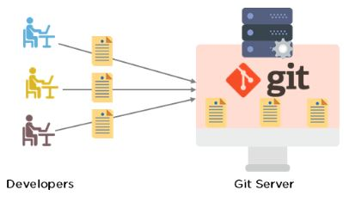

**Git Workflow:**

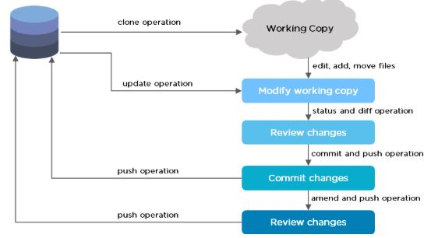

**What is GitHub?**

GitHub is an online software development platform. It's used for storing, tracking, and collaborating on software projects. It makes it easy for developers to share code files and collaborate with fellow developers on open-source projects.

**Features of Github:**

1. Easy Project Management

2. Increased Safety With Packages

3. Effective Team Management

4. Improved Code Writing

5. Increased Code Safety

6. Easy Code Hosting

**What is the difference between Git and GitHub?**

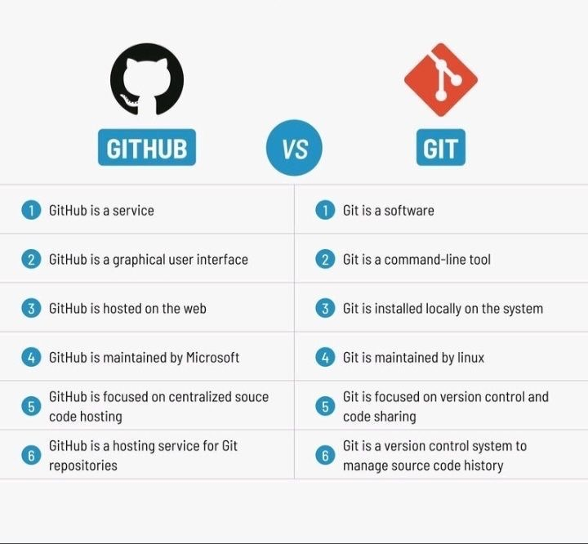

**What is Deployment?**

Deployment, in the context of software development, refers to the process of making a software application or system available for use. It involves taking the code that developers have written, tested, and configured, and then deploying it onto servers or other computing infrastructure where it can be accessed by users or other systems.

**Here are some key aspects of deployment:**

1. Build Process
2. Deployment Strategy
3. Manual Deployment
4. Continuous Deployment
5. Blue-Green Deployment
6. Canary Deployment
7. Rolling Deployment
8. Testing
9. Monitoring and Maintenance

**What is the difference between Google Drive and GitHub?**

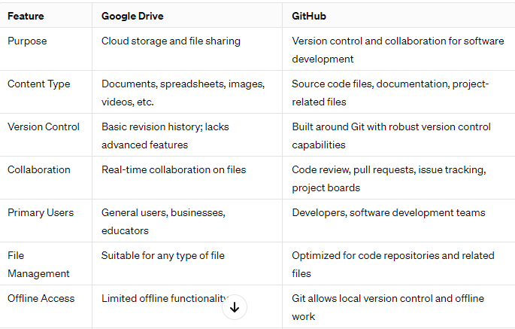

**What is the difference between Google Drive and Git?**

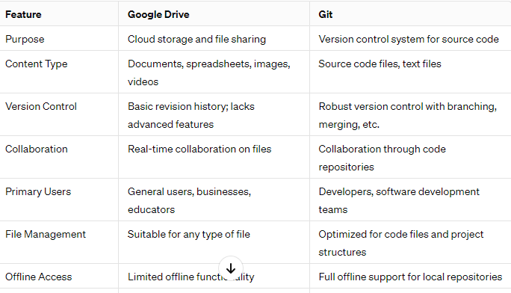

**What is Jira?**

Jira is a widely used project management tool developed by Atlassian. It's primarily designed for software development teams but is also utilized in various other industries for project tracking and task management. Jira offers a range of features to help teams plan, track, and manage their work efficiently.

**Some key aspects of Jira include:**

**Issue Tracking:** Jira allows teams to create, prioritize, and assign issues or tasks. These issues can represent various types of work items such as bugs, features, improvements, or user stories.

**Workflow Management:** Teams can define custom workflows to visualize the lifecycle of an issue, including states like to-do, in progress, testing, and done. This helps in tracking the progress of tasks and ensures that work moves smoothly through different stages.

**Agile Methodologies Support:** Jira provides support for agile methodologies such as Scrum and Kanban. Teams can plan and manage their work using agile boards, backlog management, sprints, and burndown charts.

**Customization:** Jira offers extensive customization options to tailor the tool according to the specific needs and workflows of different teams. Users can create custom fields, issue types, and workflows to match their processes.

**Integration:** Jira integrates with a wide range of other tools and services commonly used in software development and project management ecosystems. This includes integration with version control systems like Git, collaboration tools like Confluence (also by Atlassian), continuous integration tools, and many others.

**Reporting and Analytics:** Jira provides built-in reporting and analytics features to help teams track their progress, identify bottlenecks, and make data-driven decisions. Users can generate various reports, including burndown charts, velocity charts, and issue statistics.

**Collaboration:** Jira facilitates collaboration among team members by providing features such as commenting, mentioning, and notifications. This enables real-time communication and collaboration on tasks and issues.

Overall, Jira is a versatile and powerful tool that helps teams streamline their project management processes, improve productivity, and deliver high-quality results efficiently.

**What is Agile methodology ?**

Agile methodology is an approach to project management that emphasizes flexibility, collaboration, and iterative development. It was originally conceived for software development projects but has since been adopted across various industries and domains due to its effectiveness in managing complex and dynamic projects. Here are some key principles and characteristics of Agile methodology:

**Iterative and Incremental Development:** Agile projects are divided into small iterations or increments, typically lasting a few weeks (e.g., 2-4 weeks). At the end of each iteration, a potentially shippable product increment is delivered, allowing for continuous feedback and adaptation.

**Customer Collaboration:** Agile methodologies prioritize customer involvement and feedback throughout the development process. Customers or stakeholders are actively engaged in defining requirements, providing feedback on deliverables, and prioritizing features, ensuring that the end product meets their needs.

**Flexible and Adaptive Planning:** Agile projects embrace change and uncertainty, recognizing that requirements may evolve over time. Instead of detailed upfront planning, Agile teams engage in adaptive planning, where requirements and priorities are continuously refined based on feedback and changing business needs.

**Cross-functional Teams:** Agile teams are typically cross-functional, consisting of individuals with diverse skills and expertise necessary to deliver a complete product increment. This encourages collaboration, reduces dependencies, and enables teams to be self-organizing and autonomous.

**Continuous Delivery and Integration:** Agile teams emphasize continuous delivery and integration, aiming to deliver working software frequently, typically at the end of each iteration. This allows for rapid validation of ideas, early detection of issues, and quick response to changing requirements.

**Emphasis on Individuals and Interactions:** Agile methodologies prioritize individuals and interactions over processes and tools. Effective communication, collaboration, and teamwork are essential for Agile success, with face-to-face communication preferred whenever possible.

**Emphasis on Working Software:** Agile methodologies value working software as the primary measure of progress. Rather than focusing solely on documentation or adherence to a plan, Agile teams prioritize delivering tangible value to customers through functional, usable software.

**Regular Reflection and Improvement:** Agile teams regularly reflect on their processes, practices, and outcomes, seeking opportunities for improvement. Techniques such as retrospectives are used to identify strengths, weaknesses, and areas for enhancement, fostering a culture of continuous learning and adaptation.

Popular frameworks and methodologies within the Agile umbrella include Scrum, Kanban, Extreme Programming (XP), Lean Software Development, and Feature-Driven Development (FDD). Each of these frameworks provides specific guidelines, practices, and roles to support Agile principles and help teams implement Agile effectively.

**What is Waterfall Methodology?**

The Waterfall methodology is a traditional project management approach characterized by a linear and sequential process for software development and other types of projects. It was one of the earliest methodologies used for software development and has been widely adopted in various industries. Here are the key characteristics of the Waterfall methodology:

**Sequential Phases:** The Waterfall methodology follows a linear sequence of phases, where each phase must be completed before moving on to the next. The typical phases include requirements gathering, design, implementation, testing, deployment, and maintenance.

**Emphasis on Planning:** Waterfall projects often involve extensive upfront planning and documentation. Requirements are gathered and documented at the beginning of the project, and detailed design documents are created before implementation begins.

**Limited Customer Involvement:** Customer involvement tends to be limited to the initial requirements gathering phase in the Waterfall methodology. Once requirements are defined, changes to them are typically discouraged or require formal change management processes.

**Highly Structured Process:** The Waterfall methodology is characterized by a highly structured and formalized process. Each phase has its own set of deliverables, milestones, and review points, and progress is measured against predefined criteria.

**Minimal Iteration:** Unlike Agile methodologies, which emphasize iterative and incremental development, the Waterfall methodology does not typically incorporate iterations. Once a phase is completed, it is considered final, and changes are discouraged or costly to implement.

**Longer Development Cycles:** Waterfall projects often have longer development cycles compared to Agile projects due to the sequential nature of the process. This can result in longer time-to-market and less flexibility to adapt to changing requirements.

**Risk Management:** Risk management is typically addressed through upfront analysis and mitigation planning in the Waterfall methodology. Risks are identified early in the project lifecycle and addressed through proactive measures.

**Documentation Heavy:** Waterfall projects tend to produce extensive documentation at each phase of the project lifecycle, including requirements documents, design specifications, test plans, and user manuals.

While the Waterfall methodology has been widely used in the past and is still employed in certain contexts, it has been criticized for its rigidity and lack of flexibility, particularly in dynamic and uncertain environments. Agile methodologies, with their focus on adaptability, customer collaboration, and iterative development, have become more popular alternatives to the Waterfall approach, especially in the software development industry.

**What is SDLC?**

SDLC stands for Software Development Life Cycle. It is a process used by software development teams to design, develop, test, and deploy software products. The SDLC framework provides a structured approach to the entire software development process, from initial planning to final delivery and maintenance.

**Here are the typical stages of the SDLC:**

**Planning:** In this stage, the project scope, objectives, requirements, and constraints are defined. This may involve conducting feasibility studies, gathering user requirements, and creating a project plan.

**Analysis:** During the analysis phase, the gathered requirements are analyzed and documented in detail. This includes identifying the functional and non-functional requirements of the software.

**Design:** In the design phase, the system architecture and software design are developed based on the requirements gathered in the previous stages. This includes designing the overall system structure, database schema, user interface, and other components.

**Implementation:** The implementation phase involves coding or programming the software according to the design specifications. Developers write the source code, following coding standards and best practices.

**Testing:** Once the software is developed, it undergoes testing to identify and fix defects or bugs. Testing can include unit testing, integration testing, system testing, and acceptance testing to ensure that the software meets the specified requirements and functions correctly.

**Deployment:** After successful testing, the software is deployed to the production environment or released to end-users. This may involve installation, configuration, data migration, and user training.

**Maintenance:** The maintenance phase involves monitoring and supporting the deployed software to ensure its continued operation. This includes addressing user-reported issues, applying patches or updates, and making enhancements or modifications as needed.

These stages of the SDLC can be executed in a sequential or iterative manner, depending on the project requirements and development methodology used. Additionally, the SDLC framework provides guidelines and best practices for managing the software development process efficiently, ensuring that software projects are delivered on time, within budget, and with high quality.

**what are the common features of all Programming languages?**

Programming languages vary significantly in terms of syntax, semantics, and features, but there are several common features that many programming languages share. These features form the foundation of most modern programming languages and enable developers to express algorithms and solve problems efficiently. Here are some common features found in programming languages:

**Variables:** Variables are used to store data values that can be manipulated or referenced in a program. Most programming languages support the declaration, initialization, and assignment of variables.

**Data Types:** Programming languages support various data types, such as integers, floating-point numbers, characters, strings, and booleans. These data types define the kind of data that variables can hold and the operations that can be performed on them.

Operators: Operators are symbols or keywords used to perform operations on data values. Common operators include arithmetic operators (+, -, *, /), comparison operators (==, !=, <, >), and logical operators (&&, ||, !).

**Control Structures:** Control structures allow programmers to control the flow of execution in a program. This includes conditional statements (if-else, switch), looping statements (for, while, do-while), and branching statements (break, continue, return).

**Functions or Methods:** Functions or methods are reusable blocks of code that perform a specific task. They enable modular programming and code reuse by encapsulating functionality into named units.

**Input and Output:** Programming languages provide mechanisms for reading input from users or external sources (input) and displaying output to users or external devices (output). This includes functions or libraries for input/output operations, such as reading from files or displaying text on the screen.

**Error Handling:** Error handling mechanisms allow programmers to detect and handle errors or exceptions that may occur during program execution. This includes try-catch blocks, exception handling, and error reporting mechanisms.

**Comments:** Comments are used to add explanatory notes or documentation within the source code. They are ignored by the compiler or interpreter and are intended for human readers to understand the code.

**Libraries and Modules:** Programming languages often provide libraries or modules that contain pre-written code for common tasks or functionalities. These libraries extend the capabilities of the language and allow developers to leverage existing code.

**Memory Management:** Memory management features allow programmers to allocate and deallocate memory dynamically during program execution. This includes features such as automatic memory management (garbage collection) or manual memory allocation and deallocation.

**Object-Oriented Programming (OOP) Features:** Many modern programming languages support object-oriented programming (OOP) features, such as classes, objects, inheritance, encapsulation, and polymorphism. OOP allows developers to model real-world entities as objects and organize code into reusable and maintainable components.

While these features are common in many programming languages, the specific syntax and implementation may vary from one language to another. Additionally, some programming languages may include additional features or concepts not listed here, depending on their design goals and intended use cases.